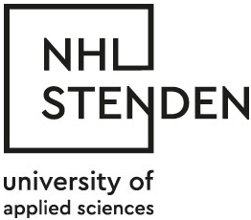

Permission form

Permission form for publication in the HBO-Knowledgebase

- The HBO-Kennisbank is a full-text database where you can find dissertations/ reports in a digital form. This means that these dissertations / reports are available for everybody through the internet all over the world.

- The student remains the person who has the copyright and therefor he can always decide to withdraw his permission for publication.

- The dissertations / reports are only published when it is graded higher than a seven and if the student and internship organization have signed this form .

Permission
- I give permission for publication of the digital version of the dissertation/ report in the HBO-Knowledgebase for a period of 5 year.

Permission with embargo
- I give permission for publication of the digital version of the dissertation/ report in the HBO-Knowledgebase after an embargo period of … months.
- Reason:

No permission
- I give no permission for publication of the digital version of the dissertation/report in the HBO-Knowledgebase.
- Reason:

Name student:

Student number:

Title dissertation /report:

Company:

Place:

Study:

Date:

Signature student: signature Internship organisation

